June 2017
Ms. Fickert’s & Ms. Azar’s
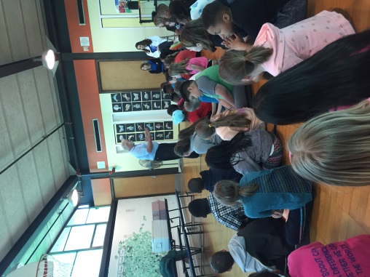

Upcoming Events & Birthdays
June 6th: Happy Birthday Amelia!

June 16th: Happy Birthday Bryanna!

Important Announcements

June 6th : Field Trip to Detroit Historical Museum.
June 8th: Field Day!
June 16th: Last Day of school, ½ day.
We are completely out of soap, Clorox wipes, and Kleenex. Any donation would be greatly appreciated!

Third Grade Newsletter
Writing & Grammar
Students will finish the unit on imaginative narrative writing. We will finish the year with a visitation of their first writing piece on Friendship.
Word Study
Students have been sorted into their Word Study groups and are working on their Wordly Wise and Words Their Way lessons. Look for students’ vocabulary and spelling words both in their take home folders and on our website.
Reading
We will continue with our small group books and working with their fluency and reading comprehension.
Math
Students will wrap up Unit 7: Fractions. Please continue to practice multiplication, division, and subtraction over the summer as these will be revisited in 4th grade.
Social Studies
Our last unit, Unit 6: Public Issues facing Michigan Citizens will be completed and reviewed.

Classroom Donation Suggestions
- Clorox Wipes
- Windex
- Air Freshener

- Kleenex
- Whiteboard Markers
- Paper towel

