March 2017
Ms. Fickert’s & Ms. Azar’s
3rd Grade Yoga Day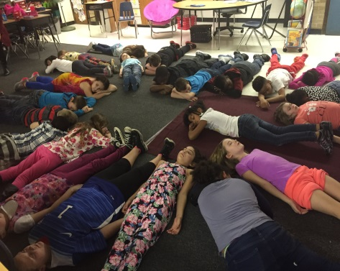

Upcoming Events & Birthdays
March 12th: Happy Birthday Jalen!!

March 14th: Happy Birthday Payton!!

Important Announcements

MCMA’s Barnes and Noble Book Fair is March 10th and 11th.
Parent/Teacher Conferences are on March 30th and 31st. Students do not have school on the 31st.
We are completely out of soap, Clorox wipes, and kleenex. Any donation would be greatly appreciated!

Third Grade Newsletter
Writing & Grammar
For this month students will be starting informational pieces. They will be focusing on the planning and organizing of a five paragraph paper.
Word Study
Students have been sorted into their Word Study groups and are working on their Wordly Wise and Words Their Way lessons. Look for students’ vocabulary and spelling words both in their take home folders and on our website.
Reading
Students will be continuing on with our history study of important people. We will also begin readers theaters to develop fluency.
Math
We have will be wrapping up Unit 4 on measurement and starting Unit 5: Writing equations to solve word problems. Please continue to practice multiplication, division, and subtraction as these will be continuously revisited.
Social Studies
We will begin Unit 4: The Growth of Michigan. Students will learn about economic activities and the environmental changes that helped to make Michigan what is it today.

Classroom Donation Suggestions
- Clorox Wipes
- Windex
- Air Freshener

- Kleenex
- Whiteboard Markers
- Paper towel

