May 2017
Ms. Fickert’s & Ms. Azar’s
Third Grade Farm Field Trip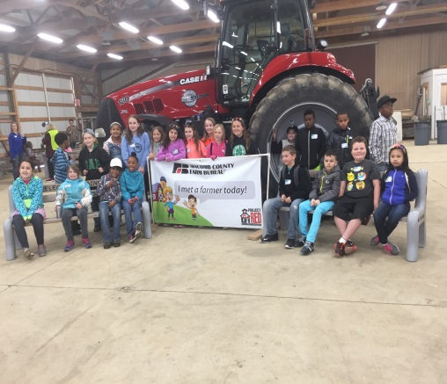

Upcoming Events & Birthdays
May 14th: Happy Birthday Khalil!

May 20th: Happy Birthday Xaioyin!!

May 28th: Happy Birthday Kaylee!!

May 29th: Happy Birthday Kalleigh!!

Important Announcements

M-step: May 15th- May 19th
May 19th: Career Day!
Memorial Day May 29th No School!
We are completely out of soap, Clorox wipes, and Kleenex. Any donation would be greatly appreciated!

Third Grade Newsletter
Writing & Grammar
Students will finish up with the poetry unit. Students will move on to imaginative narrative writing. This type of writing will allow students to be creative with their writing.
Word Study
Students have been sorted into their Word Study groups and are working on their Wordly Wise and Words Their Way lessons. Look for students’ vocabulary and spelling words both in their take home folders and on our website.
Reading
Students will finish the poetry unit. For the remainder of the year we will continue with our small group books and working with their fluency and reading comprehension.
Math
We will be finishing Unit 6 on Polygons, Perimeter, and Area and starting Unit 7: Fractions. Please continue to practice multiplication, division, and subtraction as these will be continuously revisited.
Social Studies
We will wrap up Unit 5: The Government of Michigan. The last Unit 6: Public Issues facing Michigan Citizens students will discover how public issues are solved and the decision making process.

Classroom Donation Suggestions
- Clorox Wipes
- Windex
- Air Freshener

- Kleenex
- Whiteboard Markers
- Paper towel

