October 2016
Ms. Fickert & Ms. Azar
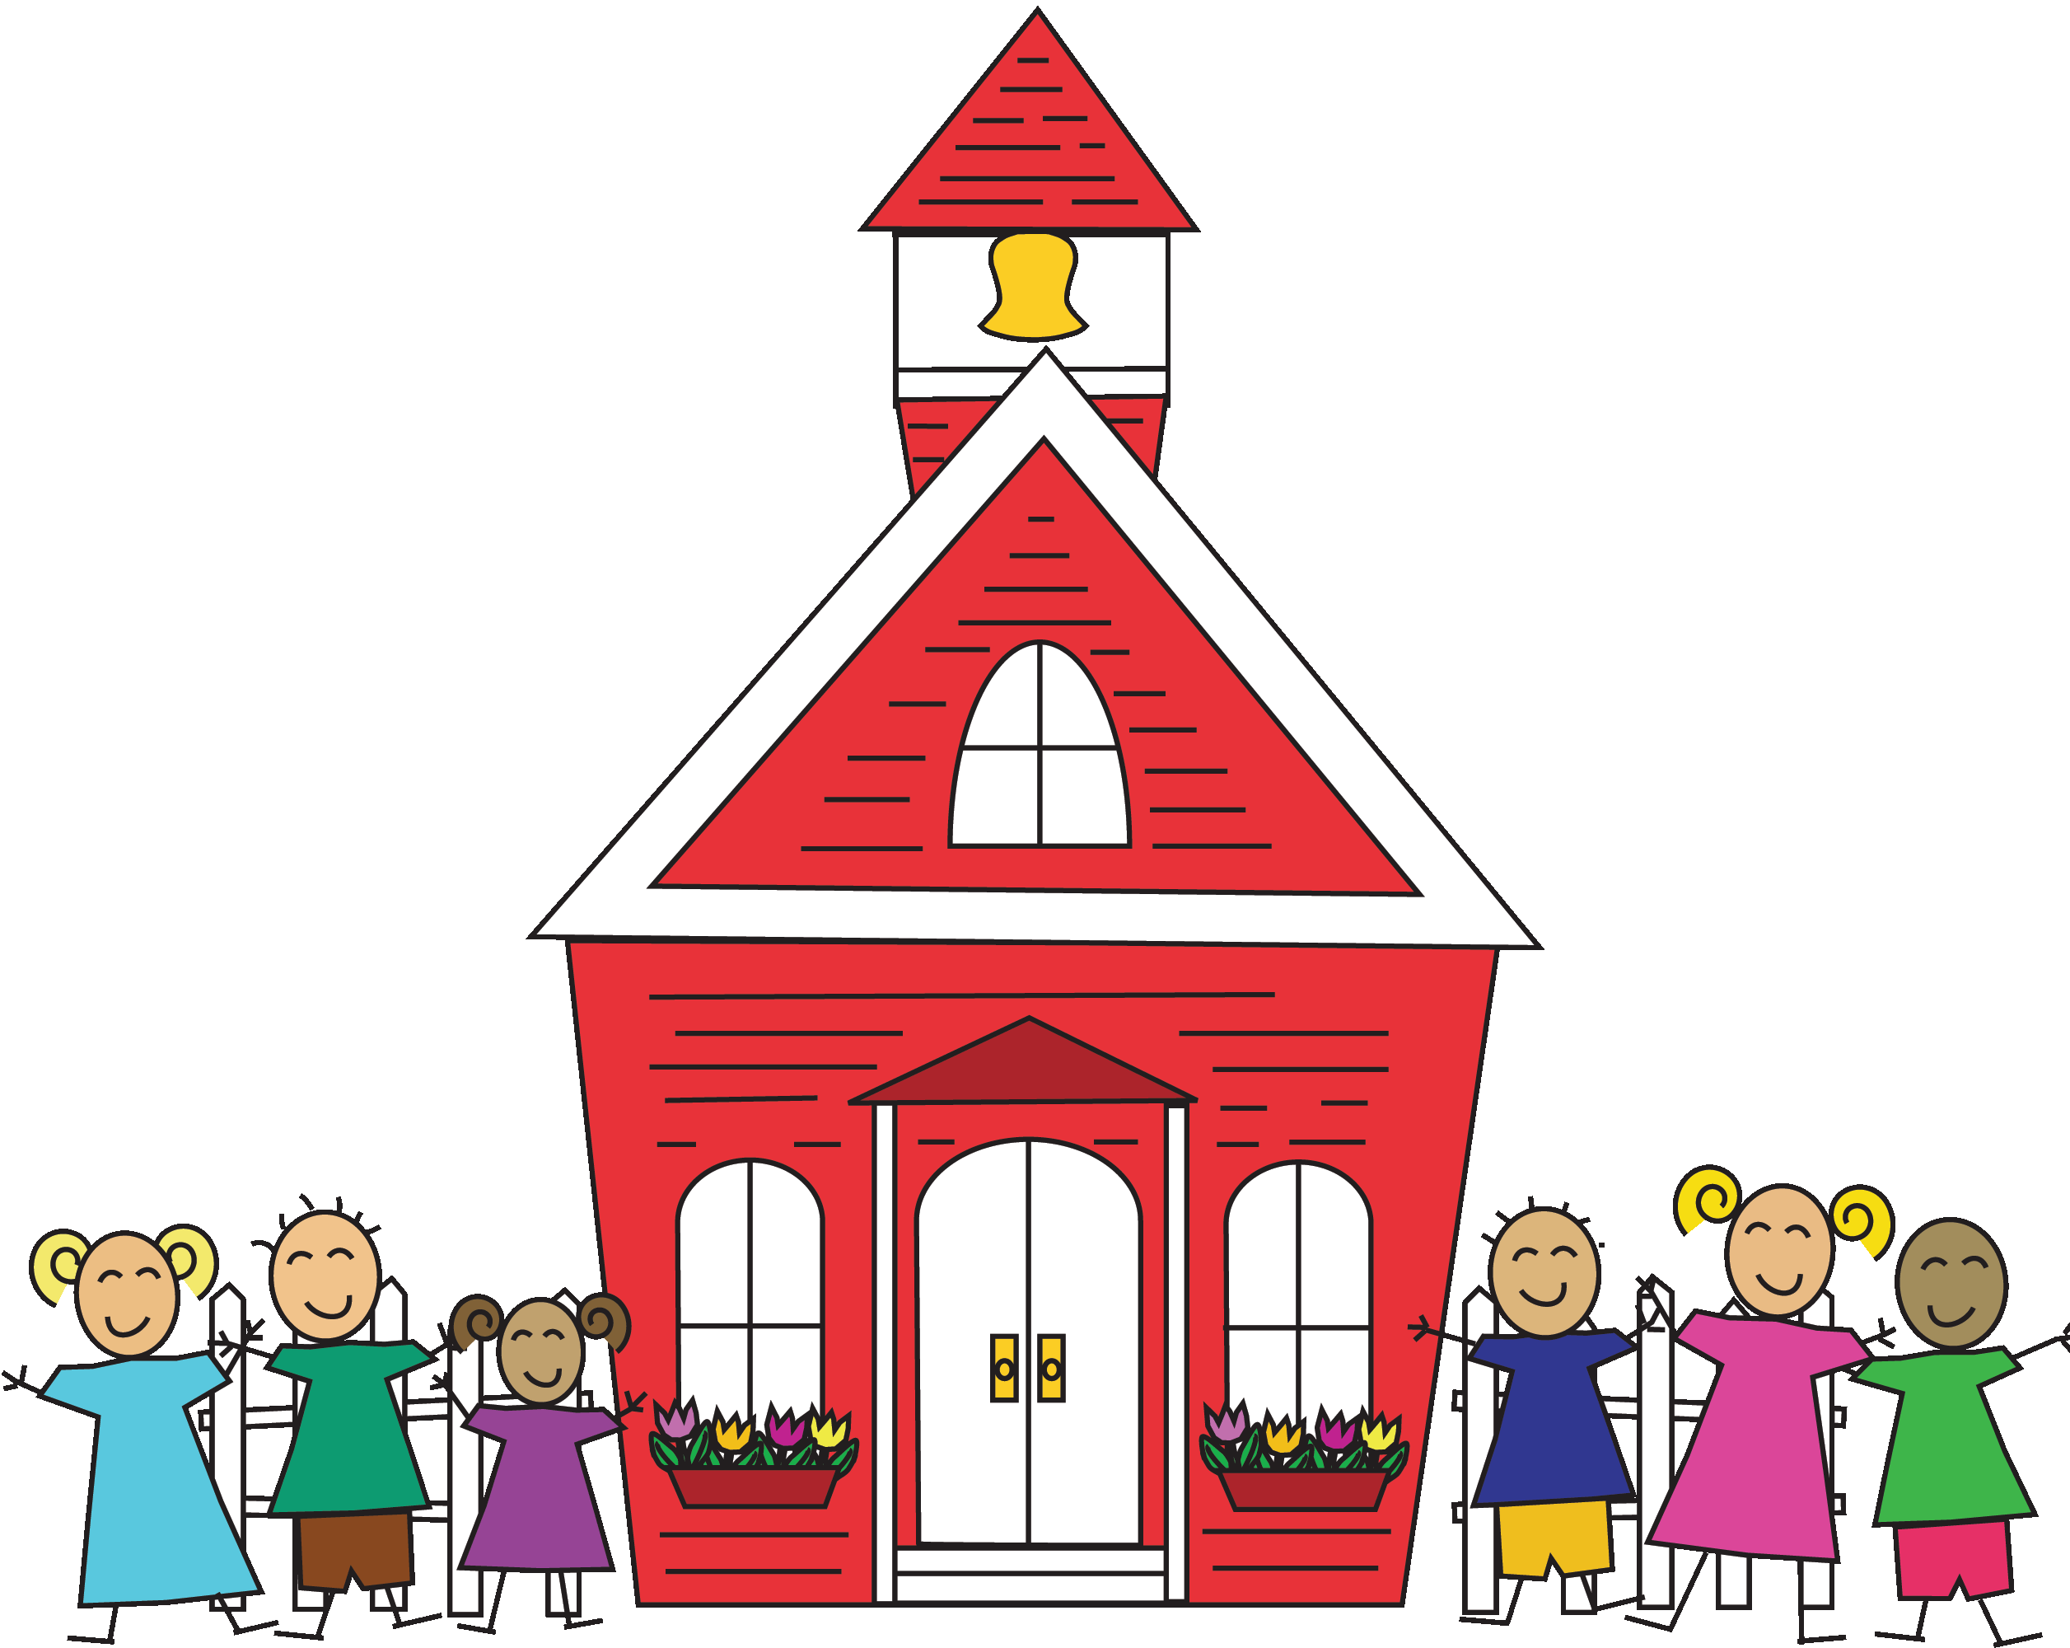

Upcoming Events & Birthdays
October 1st: Happy Birthday, Rebecca!
October 7th: Fun Run
October 14th & 15th: Barnes and Noble Book Fair
October 17th: Fall Party Sign-up Sheets and Conference Sheets Posted
October 18th: Field Trip to Greenfield Village
October 31st: Fall Party
October 31st: Half Day of School (11:30 am Dismissal)

Important Announcements
Remember to sign up for Mail Chimp on our school website to receive news blasts about important reminders and events.
Please be looking for permission slips for our field trip to Greenfield Village. We will also be looking for parent volunteers.

Third Grade Newsletter
Writing & Grammar
This month students will finish writing their personal narratives. We will then begin writing fiction stories. In grammar, we will continue with sentence structure and parts of speech.
Word Study
Students have been placed into different Word Study groups and are working on their Wordly Wise and Words Their Way lessons. Look for students’ vocabulary and spelling words both in their take home folders and on our class website.
Reading
We will be practicing different reading strategies as we read fiction books in small groups.
Math
We will continue to work on multiplication and division facts as well as word problems. Please practice these facts at home. We suggest reviewing flash cards five minutes a day.
Social Studies
We will be finishing Unit One: Geography and Map Skills. Near the end of the month we will be beginning Unit Two: Economics.

Classroom Donation Suggestions

- Hamster Bedding
- Dwarf Hamster Food
- Whiteboard Markers
- Paper Towel

